CORE JAVA ASSIGNMENT (A1)

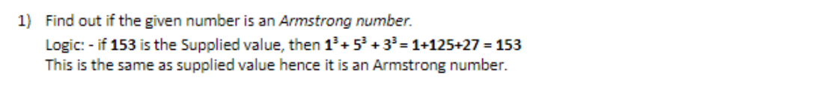

import java.util.Scanner;

public class Armstrong{

public static Scanner sc = new Scanner(System.in);

public static void main(String[] args) {

int n , m ,r ,sum=0;

System.out.println("Enter any number :");

n = sc.nextInt();

m=n;

while(n>0) {

r=n%10;

sum=sum+(r\*r\*r);

n=n/10;

}

if(sum==m) {

System.out.println("Number is armstrong:"+m);

}

else{

System.out.println("Number is not armstrong:"+m);

}

}

}



import java.util.Scanner;

public class Armstrong2 {

public static Scanner sc = new Scanner(System.in);

public static void main(String[] args) {

int n , m , r ,sum=0;

System.out.println("Armstrong No b/w 100 and 1000 are :");

for(n=101;n<=999;n=m+1)

{

m=n;

sum=0;

while(n>0)

{

r=n%10;

sum=sum+(r\*r\*r);

n=n/10;

}

if(sum==m)

{

System.out.println(m);

}

}

}

}



import java.util.Scanner ;

import java.util.\*;

public class Interest {

public static Scanner sc = new Scanner(System.in);

private static double d;

public static void main(String[] args) {

double p , r ,t , si ,ci , amount , Mult;

System.out.println("Enter principle:");

P = sc.nextDouble();

System.out.println("Enter rate:");

r = sc.nextDouble();

System.out.println("Enter time :");

t = sc.nextDouble();

si=(p\*r\*t)/100.0;

amount=p;

System.out.println("Simple interest: "+si+"\nAmount of Simple Interest:"+(p+si));

Mult = Math.pow((1+(r/100)), t);

amount=p\*Mult;

System.out.println("compound interest: "+(amount-p)+"\nAmount of Compound Interest:"+(amount));

}

}

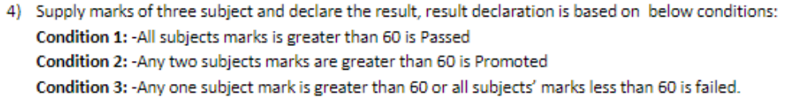

import java.util.Scanner;

public class Result {

public static Scanner sc = new Scanner(System.in);

public static void main(String[] args) {

int marks1 ,marks2,marks3;

System.out.println("Enter Marks of 1st subject: ");

marks1 = sc.nextInt();

System.out.println("Enter Marks of 2nd subject: ");

marks2 = sc.nextInt();

System.out.println("Enter Marks of 3rd subject: ");

marks3 = sc.nextInt();

if(marks1>60 && marks2>60 && marks2>60)

{

System.out.println("Pass");

}

else if((marks1>60 && marks2>60) || (marks1>60 && marks3>60) || (marks2>60 && marks3>60) )

{

System.out.println("Promoted");

}

else

{

System.out.println("fail");

} }

}

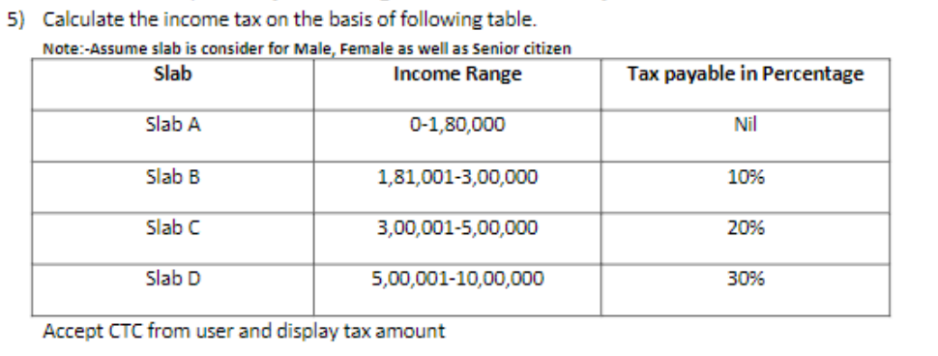

import java.util.Scanner;

import javax.lang.model.util.ElementScanner14;

public class IncTax {

public static Scanner sc = new Scanner(System.in);

public static void main(String[] args) {

System.out.println("Enter salary :");

double salary = sc.nextDouble();

double tax=0;

if(salary>0 && salary <= 180000) {

tax=0\*salary; }

else if(salary>=181001 && salary<=300000){

tax=0.1\*salary;

}

else if(salary>=300001 && salary<=500000){

tax=0.2\*salary;

}

else if(salary>=500001 && salary<=1000000){

tax=0.3\*salary;

}

System.out.println("your tax on salary : "+ tax);

}

}

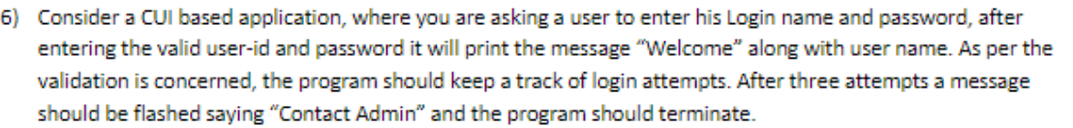

import java.util.Scanner;

public class Code6 {

public static Scanner sc = new Scanner(System.in);

public static void main(String[] args) {

int count = 1;

while(count<=3)

{

String username = "User";

String password = "password";

System.out.println("Enter user name:");

String name = sc.nextLine();

System.out.println("Enter password:");

String pass = sc.nextLine();

if(username.equalsIgnoreCase(name) && pass.equalsIgnoreCase(password)) {

System.out.println("Welocme\nYou are Signed in ");

return;

}

else {

count++;

System.out.println("Try Again !");

} }

System.out.println("Contact admin");

}

}

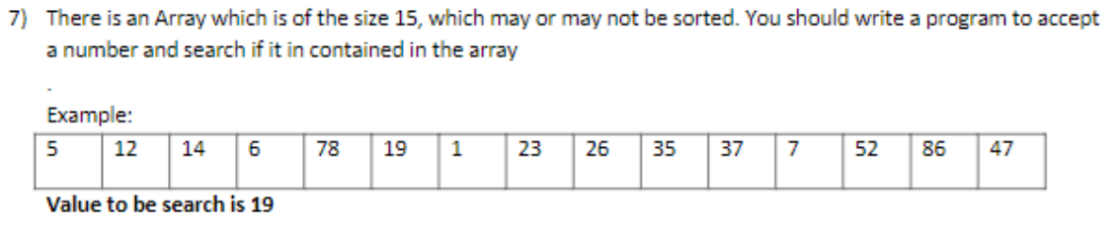

import java.util.Scanner;

public class Code7{

public static Scanner sc = new Scanner(System.in);

public static void main(String[] args) {

int ar[] = new int[15];

System.out.println("Enter 15 elements in array:");

for(int i =0;i<ar.length;i++)

{

System.out.println("enter element:");

ar[i]=sc.nextInt();

}

System.out.println("Enter element to be search:");

int x = sc.nextInt();

for(int k : ar)

{

if(x==k)

{

System.out.println(x+" is present in the array !");

return;

}

}

System.out.println(x+" is not present in the array !");

}

}

8. Use bubble sort in above table in order to sort the array given

import java.util.Scanner;

public class Code8 {

    public static Scanner sc = new Scanner(System.in);

    public static void main(String[] args) {

    int i ;

System.out.println("Enter No of elements to be insert in array:");

    int size = sc.nextInt();

    int ar[] = new int[size];

    for (i = 0; i < size; i++) {

      System.out.println("enter element:");

            ar[i] = sc.nextInt();

        }

    System.out.println("Before sorting array as:");

    for (int k : ar) {

            System.out.print(k + "\t");

        }

    for (i = 0; i < size; i++)

        for (int j = 0; j < size - 1; j++)

            if (ar[j] > ar[j + 1]) {

                int temp = ar[j];

                ar[j] = ar[j + 1];

                ar[j + 1] = temp;

              }

    System.out.println("\nAfter sorting array as:");

        for (int k : ar) {

            System.out.print(k + "\t");

        }

    System.out.println("\nEnter element to be search in array:");

    int x = sc.nextInt();

    for (int k : ar) {

          if (x == k) {

    System.out.println(x + " is present in the array !");

    return;

      }

  }

  System.out.println(x + " is not present in the array !");

  }

}